# Weighted Average Design Outline

## Constants

1. The different weights for the graded subjects
   1. Quiz = .10
   2. Discussion = .30
   3. Programming Assignment = .60
2. The list of student names; Alice, Bob, John and Jane

## User Inputs

1. The name of the student
2. Each student's grade in the quiz, discussion and programming assignment

## Program Output

1. The name of the student with the highest average and their average
2. Error message, if the user enters a name of a student not in the defined student names

## Steps on how to achieve this

1. Prompt the user for the name of a student
   1. If the name of the student is not in the student name list, print a response and exit the program
2. Assign the program a default highest grade and a default best student name
3. Output the student's name and prompt the user to successively input the student's quiz, discussion and programming assignment grades
4. For each, multiply by the defined weights specified in the contacts and sum the results to get the weighted average of each student
5. Check if the student’s grade is greater than the assigned default highest grade
   1. If it is higher than the value of the highest grade, assign the student’s grade to the highest grade variable and the student’s name to the default best student variable
6. Return the highest grade and the best student’s name
7. Output/Print the name of the best student and the grade that they have, which is the highest grade

## Test Cases

| Test Case | Student Name(s) | Quiz Grade | Discussion Grade | Programming Assignment Grade | Output |
| --- | --- | --- | --- | --- | --- |
| A student name that doesn’t exist | Doe | - | - | - | The student Doe does not belong to this class |
| Students that exist | (Alice, Bob, John, Jane) | Alice - 34 Bob - 45 John - 53 Jane - 60 | Alice - 78 Bob - 82 John - 86 Jane - 89 | Alice - 69 Bob - 71 John - 79 Jane - 87 | Jane is the student with the highest grade of 84.9 |

## Screenshots

1. A student name that doesn’t exist

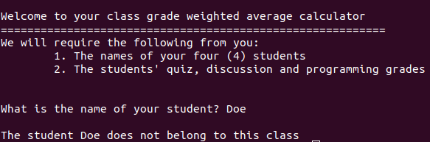

1. Students that exist

